1.What is C language?
C is a powerful, general-purpose programming language known for its speed and efficiency, used to create a wide range of software, from operating systems and embedded systems to applications.
2.What are the applications of C programming?
C is mostly utilized in the development of system software and desktop applications. Some examples of C programming applications are listed below.

Animation and Gaming: C is faster than Python or Java since it is a compiler-based language. It has also established itself in the gaming industry. Some of the most basic games, such as The Dino Game, The Snake Game, Tic-Tac-Toe, and others, are coded in C languages.
Operating Systems for Computers: The C programming language was used as the operating system’s high-level programming language for the first time in UNIX. The C programming language was later utilized to write Microsoft Windows and a number of Android apps.
Embedded systems: C programming is known as the finest option for scripting applications and drivers for embedded systems since it is closely tied to machine hardware.
Compiler Design: One of the most common applications of the C programming language was compilers. Compilers for a variety of other languages were designed with the relationship between C and low-level languages in mind, making it easier for machines to understand. Many popular compilers, such as Clang C, Bloodshed Dev-C, Apple C, and MINGW, were written in C.
MySQL: MySQL is another relational database-related open-source project. It was written in C/C++, which is a programming language.
Google System: The Google Chrome browser and the Google File System were built using C/C++. In addition, the Google Open Source community handles a huge number of C/C++ programming language projects.
Thunderbird And Mozilla Firefox: Mozilla Firefox and Thunderbird were both open-source email programs that were free to use. As a result, they have to be written in C/C++.
User interface: Adobe Photoshop has been one of the most extensively used image editors since the dawn of time. It was written in the C programming language from start to finish. Illustrator and Adobe Premiere were also created with C.
3.What is a variable?
A variable is a quantity, symbol, or characteristic that can change or vary.
4.What are different data types in C programming?

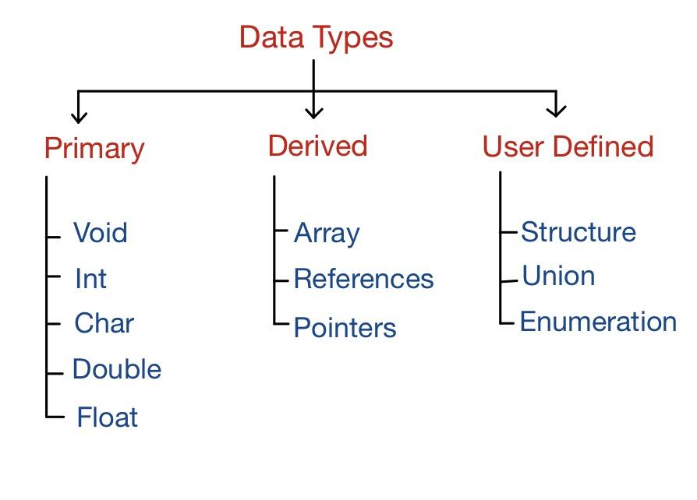5.What is format specifier?
A format specifier in C programming is a special character sequence used in input and output functions (like printf and scanf) to specify the type of data to be formatted or read. It tells the compiler how to interpret the data type of the variable being input or output
.Common format specifiers include:
%d for integers
%f for floating-point numbers
%c for characters
%s for strings
Format specifiers are essential for correctly displaying or reading values of different data types in C.

